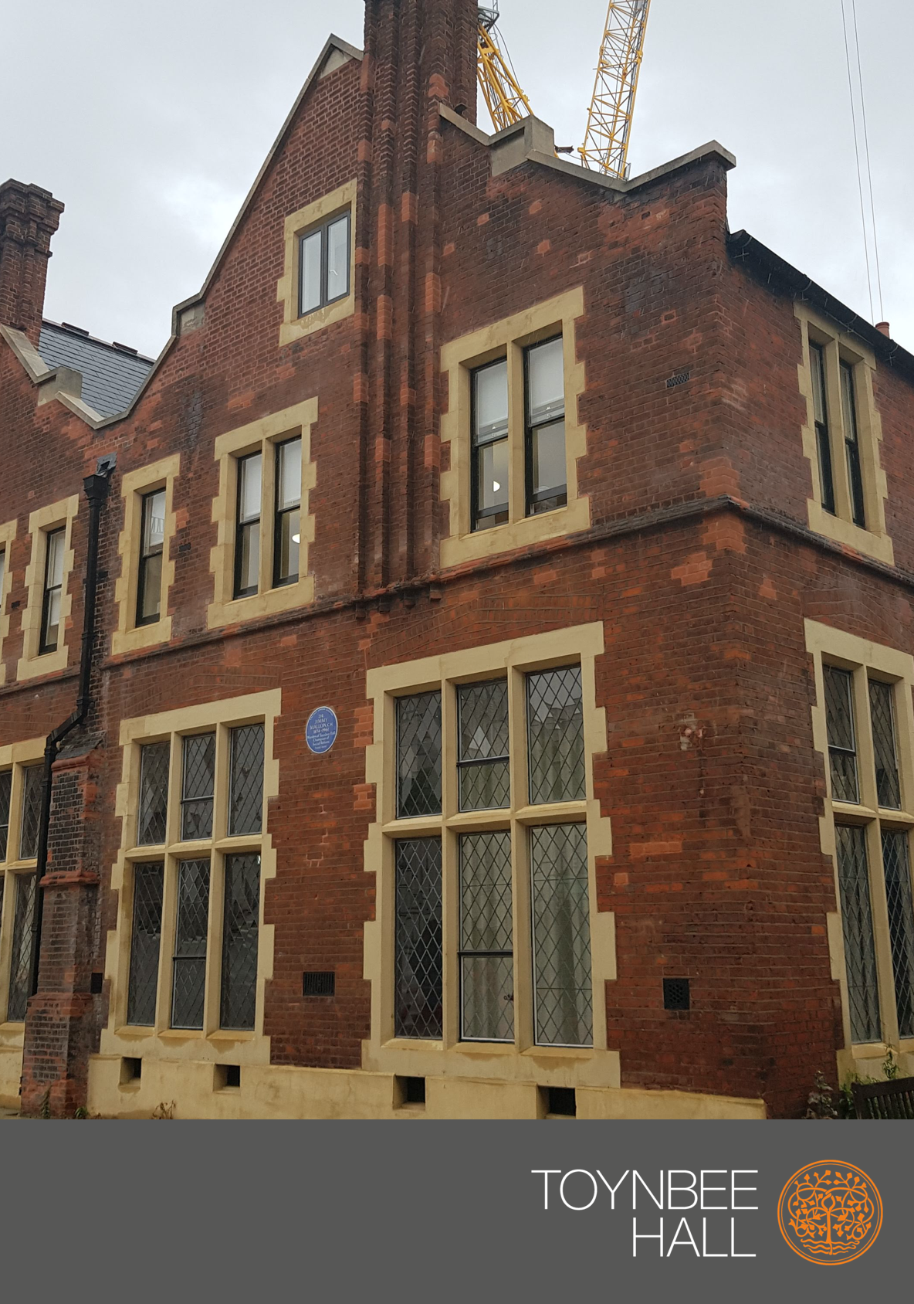

Dear Candidate,

Toynbee Hall was created in 1884 by Samuel and Henrietta Barnett who established the charity in response to a growing realisation that enduring social change would not be achieved through the existing individualised and piecemeal approaches. The radical vision was to create a place for future leaders to live and work as volunteers in London’s East End, bringing them face to face with poverty, and giving them the opportunity to develop practical solutions that they could take with them into national life.

Many of the individuals that came to Toynbee Hall as young men and women – including Clement Attlee and William Beveridge – went on to bring about radical social change and maintain a lifelong connection with Toynbee Hall. Today, it is as important as ever for Toynbee Hall to continue to identify emerging needs, pilot new responses, and persuade local and national leaders to adopt them. We have been a catalyst for social reform in the UK for 135 years, and continue to create new ways to help those who find themselves in poverty today – whatever their age or background.
Thank you for your interest in a career at Toynbee Hall.

On our website, you will have found and read all the information you need to help you decide to apply for a position with us. Please take the time to read all these documents including any advertisements and web content relevant to the role. You would not want to miss the deadline by which to apply and who/where to send your application. Please follow the instructions when you complete the application form, we want you to have the best chance to be shortlisted.
We prefer your application to be submitted in Microsoft Word format. However, if you want to use a different format or if you need further assistance, please let us know.
If you have not been contacted within three weeks of the closing date, please assume that your application has been unsuccessful. Unfortunately, we are unable to provide feedback on applications to individuals who have not been selected for an interview, due to the high volume of applications we receive for each role.
Good luck,

People Team

For HR Purposes only – Keep separate from application form Applicant number:

Application for the post of: ____________________

Closing date for completed applications:

⎯⎯⎯⎯⎯⎯⎯⎯⎯⎯⎯⎯⎯⎯⎯⎯⎯⎯⎯⎯⎯⎯⎯⎯⎯⎯⎯⎯⎯⎯⎯⎯⎯⎯⎯⎯⎯⎯⎯⎯⎯⎯
Please tell us how you found out about this vacancy:
(If you found it on the internet, please specify which website)

____________________________________________________________________________

Personal Details
First name
Surname
Address
City, County, Postcode
Phone number |  | Mobile
Email address

For HR Purposes only Applicant number:
Post applied for:

Please write your professional experience, including your relevant skills and qualifications; and a list of any professional associations and affiliation. Please start with the most recent ones.

Company Name

Dates of employment | From mm/yyyy to mm/yyyy
Main duties and responsibilities | -  -  -  -
Relevant skills and qualifications

Company Name

Dates of employment | From mm/yyyy to mm/yyyy
Main duties and responsibilities | -  -  -  -
Relevant skills and qualifications

Company Name

Dates of employment | From mm/yyyy to mm/yyyy
Main duties and responsibilities | -  -  -  -
Relevant skills and qualifications

Company Name

Dates of employment | From mm/yyyy to mm/yyyy
Main duties and responsibilities | -  -  -  -
Relevant skills and qualifications

Supporting statement:

Please give your reason for applying for this post at Toynbee Hall. It is important in doing so to read the Person Specification and demonstrate how you meet each requirement by giving details of your skills and relevant knowledge, experience, and achievements. This should be no more than two sides of A4.
____________________________________________________________________________

For HR Purposes only – Keep separate from the application form

Other details:

Do you hold a current driving licence? Yes/No (delete as applicable)

Do you have the right to work in the UK? Yes/No (delete as applicable)
(We are unable to consider your application if you do not have the right
to work in the UK under the Asylum and Immigration Act 1996)

Have you been convicted of any criminal offense (including both Yes/No (delete as applicable)
spent and unspent convictions) or received a caution, reprimand
or warning, under the Rehabilitation of Offenders Act 1974?
If yes, please attach details on a separate sheet.

The successful candidate may have access to vulnerable people, therefore Toynbee Hall may carry out Enhanced Disclosure Barring Service checks. Previous convictions do not necessarily constitute a bar on selection, but failure to disclose such convictions will do so and would result in immediate termination of your services.

Are you related to any member of Toynbee Hall staff or its Yes/No (delete as applicable)
Governing Body? If so, please specify:

Any candidate who directly or indirectly canvasses a member of Toynbee Hall staff or its Governing Body will be disqualified. Toynbee Hall does not bind itself to appoint any applicant.

If offered employment, you will be required to complete a Medical Questionnaire. Are you prepared to undergo a medical examination before starting employment?
Yes / No
⎯⎯⎯⎯⎯⎯⎯⎯⎯⎯⎯⎯⎯⎯⎯⎯⎯⎯⎯⎯⎯⎯⎯⎯⎯⎯⎯⎯⎯⎯⎯⎯⎯⎯⎯⎯⎯⎯⎯⎯⎯⎯⎯⎯⎯⎯

Employment References

Please give the names and contact details of two independent referees. Where possible, one should be your current or most recent employer, and the other a previous employer. Where you are unable to supply the names of a current or recent employer you must provide the details of two appropriate alternative referees. References will be taken up once a job offer has been verbally accepted.

Name:

Position:

Organisation:

Address:

Email address:

Telephone number:

Name:

Position:

Organisation:

Address:

Email address

Telephone number:

⎯⎯⎯⎯⎯⎯⎯⎯⎯⎯⎯⎯⎯⎯⎯⎯⎯⎯⎯⎯⎯⎯⎯⎯⎯⎯⎯⎯⎯⎯⎯⎯⎯⎯⎯⎯⎯⎯⎯⎯⎯⎯⎯⎯⎯⎯

For HR Purposes only – Keep separate from the application form

In accordance with the Data Protection Act 1998, I give my consent for the information contained in this form, including any defined as ‘sensitive personal data’, to be processed in accordance with the policy of Toynbee Hall for the purposes of recruitment and employment. I understand that if I am appointed, this application form will form part of my personal file and that if I am not appointed it will be stored for up to a year and then destroyed.

I confirm the information I have supplied above is, to the best of my knowledge, true and accurate. I understand that deliberate misrepresentation or omission of factual information may lead to dismissal/legal action.

If appointed, I am prepared to accept the conditions set out in the job description and contract.

Signed Dated
Please return the completed form not later than the closing date shown at the top of page 1 to:
HR Department, Toynbee Hall, 28 Commercial Street, London E1 6LS. We accept emailed applications to: application@toynbeehall.org.uk

For HR Purposes only – Keep separate from application form

Equal Opportunities Monitoring Form

Post Applied for:
Date:

Toynbee Hall is committed to equal opportunities in its employment policies, practices, and procedures. To help us monitor the effectiveness of our equal opportunities policy, please could you fill in the following form. This will be kept separate from your application form and treated in the strictest confidence and will be held in accordance with the Data Protection Act 1998. In signing this form you agree to the Company holding and processing the data below for the legitimate business reasons outlined above. This form will not have any impact on the final recruitment decision.

Please answer the following questions by ticking as appropriate:

1. What is your gender? Male ☐ Female ☐ Non-Binary ☐

2. Are you registered disabled? Yes ☐ No ☐

3. How would you describe your ethnic origin?

Asian: | Black: | White: | Dual heritage:
Bangladeshi  ☐  Chinese  ☐  Indian  ☐  Pakistani  ☐  Other:  ☐ | African  ☐  Caribbean  ☐  Other:  ☐ | English  ☐  Scottish  ☐  Welsh  ☐  Irish  ☐  Other:  ☐ | White and Caribbean  ☐  White and African  ☐  White and Asian  ☐  Other:  ☐

4. What is your age range?

18 – 24 | ☐
25 – 34 | ☐
35 – 49 | ☐
50 – 59 | ☐
60+ | ☐

5. Where did you find out about this vacancy? _____________________________

6.

What was the occupation of your main household earner when you were aged about 14?
- Modern professional and traditional professional occupations such as teacher, nurse, physiotherapist, social worker, musician, police officer (sergeant or above), software designer, accountant, solicitor, medical practitioner, scientist, civil engineer or mechanical engineer | ☐
- Senior, middle or junior managers or administrators such as finance manager, chief executive, large business owner, office manager, retail manager, bank manager, restaurant manager, warehouse manager | ☐
- Clerical and intermediate occupations such as secretary, personal assistant, call centre agent, clerical worker, nursery nurse | ☐
- Technical and craft occupations such as motor mechanic, plumber, printer, electrician, gardener, train driver | ☐
- Routine, semi-routine manual and service occupations such as postal worker, machine operative, security guard, caretaker, farm worker, catering assistant, sales assistant, HGV driver, cleaner, porter, packer, labourer, waiter or waitress, bar staff | ☐
- Long-term unemployed (claimed Jobseeker’s Allowance or earlier unemployment benefit for more than a year) | ☐
- Small business owners who employed fewer than 20 people such as corner shop owners, small plumbing companies, retail shop owner, single restaurant or cafe owner, taxi owner, garage owner | ☐
- Other - such as retired, this question does not apply to me, I don’t know) | ☐
- I prefer not to say | ☐

Thank you for completing this questionnaire.

Toynbee Hall

